A Multi-Modal Video Communication System for Real-Time Translation of Speech, Text, and Sign Language using Computer Vision and Natural Language Processing for Speech and hearing-impaired people
Akbar Badhusha Mohideen, M. K. Nagarajan, Velpula Jeevan Kishore Babu, Kamale Varun, Gangula Sivasankaravaraprasad, Chekuri Uma Mahesh
Kalasalingam academy of research and education
Srivilliputtur, Tamilnadu, India 626126

Corresponding author: jeevankishorbabu9985826355@gmail.com
Abstract. There is the communication barrier between the deaf and hearing community that poses a serious obstacle to the social and professional integration. Conventional assistive technology tends to tackle these requirements in a piecemeal way, providing different tools that support speech-to-text transcription, and sign language recognition. This paper presents a new Multi-Mode Video Communication System which aims at offering an integrated real-time translation platform. The system allows the flow of two-way conversations in real time whereby spoken language is translated to text and sign language and vice versa in the same video conferencing platform. We use Computer Vision to enable a powerful, real-time sign language recognition of the video feed and Natural Language Processing to convert speech-to-text and text-to-speech. These technologies, when all integrated into one structure, form a complete and easy to use communication tool that does a lot to improve interoperability. The purpose of this work is to decrease the technological burdens of cross-community communication, which will ensure a more convenient and open approach to people who use speech, text, or sign language to communicate.
Keywords. Multi-modal communication, real-time translation, sign language recognition, computer vision, natural language processing, deep learning, video conferencing, speech-to-text, sign language-to-speech, accessibility.

Introduction
Communication is a key component to being human yet there are thousands of people with sensory disability, specifically those who are deaf or hard-of-hearing, are limited in their ability to effectively communicate in real-time. The existing assistive technologies are largely disjointed; individually they only provide support on one particular communication mode e.g. converting speech to text or reading the signs; offline. This makes the interaction between the sign language user and the general public not to be in smooth flow and therefore breaks a non-spontaneous interaction between them.

In order to resolve this important problem, we introduce a solution referred to as A Multi-Modal Video Communication System. The objective of this platform is to offer a seamless, end to end platform of fluid discussions by offering real-time translation of speech, text and sign in one video conferencing platform. The technology provides a smooth communication between persons and does not depend on the way individuals prefer to communicate past the technological segregation barriers.

The special characteristic of our system is that it has a bi-directional translation capability. We use Computer Vision to read sign language gestures in real-time video and translate them into a text and spoken word. At the same time, it is also possible to use the system. Natural Language Processing (NLP) to convert speech to a caption and then the use of a visual avatar provides a sign language representation to the user. This two-way translation support increases the usability and provides a smooth flow of conversation. The design and organization of our system in this paper are described in detail, and the implementation of how the interaction of the real-time video communication technologies with the top AI translation services is incorporated is explained. We also delve on the importance of our system in delivering two-way communication where other tools are failing in delivering this. The proposed work contributes to the expanding body of literature on assistive technology and shows a solution of a scalable and robust nature in terms of filling the communication gap.

The paper is split into seven sections. Section II will cover the Literature Review that will cover those studies that have been conducted on current sign language recognition and translation systems. Section III outlines the Problem Statement, which involves the principal communication barriers and failure of the existing solutions. Section IV is the Proposed Methodology, which describes and explains how Computer Vision, Natural Language Processing and WebRTC can be combined. Section V describes the Implementation, tools and technologies and prototype set up. In section VI, we present the Results and Analysis, in which we draw comparisons between the work of our system and existing works. Finally, a concluding part (Section VII) will provide the Future Work directions of the paper.

LITERATURE REVIEW
Most recent developments in deep learning and computer vision significantly increased the rate of sign language recognition systems. El-Sayed et al.¹ proposed a MediaPipe-based, deep-learning-based end-to-end interpretation framework in American Sign Language (ASL). Their system was found to be very accurate and low latency in various environments but it needed a large dataset to be trained and finds difficulties with real-time deployment.
This work was furthered by Agre et al.² who came up with a bi-directional translation system that translates sign language into text and speech as well translating spoken language into sign language through an animated avatar. The method is very inclusive in both directions and gives the opportunity to communicate two-way but is very sensitive to language datasets and variations in accents. In the same vein, Mukherjee et al.³ suggested a real-time captioning system to video meeting, which automatically generates captions during sign gestures, which greatly enhances accessibility in conference platforms. Nevertheless, the system cannot process a wide variety of gestures because of constraints in the datasets.
In the case of Indian Sign Language (ISL), Pandey et al.⁴ suggested a model of vision-based translation with CNNs, LSTMs, and Transformers. This hybrid design had high classification performances and it was promising in real time implementation, however it was consuming considerable amounts of computation and was affected by low availability of data. Ngugi⁵ elaborated on a computer vision and LSTM-based text translator with NLP to convert text and used it to provide real-time translation through a web interface. It was limited to environmental conditions and the internet connectivity even though it had benefits.
Lightweight, web-enabled systems have been given attention by other researchers. Repal⁶ have created a web application based on two-way sign-to-speech/text conversion implemented with MediaPipe and TensorFlow, as well as multi-language and recording features. Devi et al.⁷ introduced a CNN and YOLO-based translator which is capable of providing text and speech, which proves to be reliable with structured input, but will need high-quality video to remain accurate. Liu et al.⁸ exploited an advanced architecture, that is, ResNet152, Feature Pyramid Networks (FPN), and Detection Transformers (DETR), to attain a recognition accuracy of 96.45%. Although it was very effective, this approach required large datasets and computing.
Combining the ideas of recognition and communication technologies, Shaikh and Hadiyal⁹ created a video-calling application using sign language which transcoded ASL motionless signs to text and allowed more natural communication. The system however had a limitation in that it was restricted to a static gesture of choice and could not embrace dynamic movements. This direction was continued by Kumar et al.¹⁰ with a WebRTC-based video chat app with an inbuilt sign detection application with TensorFlow. Their prototype proved the practicability of integrating accessibility directly into conferencing platforms, but could not perform well under light conditions and in low bandwidth.
Modelling of time has been discussed as well. Huang and Chouvatut¹¹ merged ResNet to extract spatial features with LSTM to capture temporal dependencies in video-based recognition with an accuracy of 86.25. This spatio-temporal method offered more details but required big datasets and processing power. On the same note, Mukherjee and Akhtar¹² used real-time captioning by a browser extension, which generates automatic subtitles as calls are happening. Although it was inclusive, the system had compatibility issues, and still relied on quality of data.
More research has explored solutions in ISL. Varsha and Rajeswari¹³ developed a system of deep learning-based ISL recognition; the researchers obtained a higher recognition rate with the help of neural network structures. However, it did not cope with end-to-end, sentence-level translation tasks because of a small variety in datasets. Debevc et al.¹⁴ offered an early multimedia-based accessibility system that provided sign videos, captions and audio services to the aurally handicapped person. It was not real-time, and limited to predetermined content, but was innovative at the time.
Mehta et al.¹⁵ provided accessibility in the form of automated 3D avatars to synthesize captions, and transform speech into ISL animations. This approach made deaf students learn better but questioned the aspect of the naturalness of avatars. Lastly, Suthagar et al.¹⁶ trained a gesture-to-text/Speech translator with Support Vector Machines (SVMs) and obtained more than 95% accuracy rate on the alphabets and numbers. The system was however, in need of good lighting and poor at continuous signing.
Overall, these works indicate that much has been achieved in the area of sign language research and such solutions as CNNLSTM hybrids and DETR-based recognition, WebRTC-based video chat and 3D avatar systems are finding their place. Although these developments have been done, the majority of developments are aimed at single-function tools, i.e. sign-to-text, text-to-speech or captioning. Very few pieces of works propose a complete multi-modal framework that can provide real-time, two-way communication in video conferencing systems. In response to this gap, our proposed system combines computer vision, natural language processing with WebRTC to create a single platform that allows even speech, text, and sign language translation to proceed without misunderstanding and improves inclusivity and accessibility.
In conclusion our project is a multi-modal video communication system designed to make real-time conversations easier and more inclusive for people who are deaf or hearing-impaired. It works like a video calling app but with added features that allow communication through speech, text, and sign language translation in the same platform. With this tool, dumb and hearing-impaired people can communicate naturally with normal hearing people, removing barriers in everyday conversations.
The Difference Between Existing Systems and Our System:
• A complete communication platform: Many earlier projects focus on just one part of the problem like only converting sign language to text or using avatars, our system combines sign detection, speech-to-text, and text-to-speech into a single, seamless tool.
• Real-time two-way interaction: Instead of generating captions or translations after a video is recorded, our system supports instant, natural, back-and-forth conversations, ensuring accessibility for everyone during live communication.
Overall, our project ensures end-to-end accessibility by enabling deaf or hearing-impaired individuals to communicate effectively with both peers and normal hearing people, making conversations more inclusive and widely deployable than earlier prototypes.

PROBLEM STATEMENT
Communication between hearing and the deaf is often stifled due to technological fragmentation and absence of a holistic and real time solution. Current assistive technologies can be generally described as stand-alone applications, and provide a toolkit to do real-time speech-to-text transcription, or offline sign language recognition. This single-purpose design does not allow spontaneous and uninterrupted dialogues, and the user is required to use a set of tools that do not work together (or a human translator) to resolve the communication gap. In particular, what is lacking is acute deficiency of a single, multi-modal platform in which these functionalities are merged into one video conferencing platform. The basic issue that the project will solve is the absence of a real-time system that can convert speech into sign language, and the reverse in the same video stream, thus, cannot facilitate a bi-directional, natural conversation. The lack of such a unifying system restricts social inclusion and professional opportunities of the deaf community and places a major obstacle on the way of communication accessibility.

PROPOSED METHODOLOGY
The development of our proposed system is done in an incremental approach to integrate sign recognition, speech processing, and real-time communication on a single platform. The first, sign language datasets, is collected and prepared through identification of key points of the hands, face and body that is then labeled to be used in training and testing. These data sets are utilized to train models that identify signs and translate them into text.

Meanwhile, speech recognition can be done with the help of applications such as Whisper or cloud APIs, to convert speech to text. The resulting text outputs are then further rendered in two formats: they may be synthesized into speech with text-to-speech synthesis, or translated into sign language with sign clips recorded on file or 3D avatars. All these elements are combined in a video calling solution that operates in the real-time created using WebRTC where video, audio, captions, and sign animations are synchronized to ensure seamless communication. The node.js and Express framework are combined with MongoDB to store information and Python-based microservices to execute machine learning models in the backend. Lastly the system undergoes a latency and usability test, is optimized to achieve better performance and is rolled out across cloud environments using the containerization technique to scale.
1) Data Collection and Preparation
Collect sign language datasets (e.g., ISL datasets) and record custom sign samples for training. Detect key points of hands, face and body with MediaPipe or OpenPose. Labeled preprocessed data to be used in training and testing.
Input: Raw sign language videos
Output: Clean dataset with key points and annotations
2) Sign Language Recognition
Process key point sequences with Spatio-Temporal Graph Convolutional Networks (ST-GCN) or Transformer-based models. Give the model signs to be categorized into words or sentences. Provide text output with confidence scores.
Input: Key point sequences
Output: identified text (e.g., Hello, Thank You)
3) Speech Recognition (Asr)
Record the microphone of a hearing user. Use Whisper (local) or cloud APIs (Google/Azure) for speech-to-text conversion. Generate partial and final transcripts with time alignment.
Input: Live audio stream
Output: Text transcripts
4) Text-To-Speech Conversion
Turn the text that is recognized by the sign user into a natural voice. Use cloud APIs (Google, Amazon Polly, Azure TTS) or open-source models like Coqui TTS.
Input: Sign recognition text generated.
Output: Audio speech
5) Text-To-Sign Translation
The text identified on the map and swapped with a preexisting sign clip or created an avatar animation in 3D with React Three Fiber. Include facial expressions for natural signing.
Input: Speech transcripts (text)
Output: Sign avatars or stitched sign clips.
6) Real-Time Video Call Integration
Implement WebRTC for peer-to-peer video/audio streaming. Signaling and session management Use Node.js backend. Synchronize audio, captions, and avatar animations for smooth interaction.
Input: Video & audio streams, ML payloads
Output: Coordinated communication session, captions, voice and sign animations.
7) Backend And Database Management
Application Backend: Node.js & Express to signal, API calls, and WebSocket.
Database: MongoDB for user profiles, vocabulary storage, and session logs.
ML Service: Python & FastAPI to provide the ML models through microservices using docker.
8) Testing And Optimization
Measure latency (end-to-end <500 ms). Optimize and quantize models to run (ONNX Runtime, TensorRT). Perform usability and accessibility testing on actual users.
9) Deployment
Deploy frontend on Vercel, backend on Render and ML services on AWS with GPU support. Containerize all services with Docker for portability and scaling.

In short, the methodology unites several AI elements - sign language recognition, speech-to-text, text-to-speech, and text-to-sign translation into one real-time video communication framework. A combination of these components using WebRTC and a powerful back-end will make the platform allow constant two-way communication between deaf or hard-of-hearing people and hearing users. The design is practical, low-latency, and scalable in nature to ensure that the system can be depended upon in the actual communication environment.
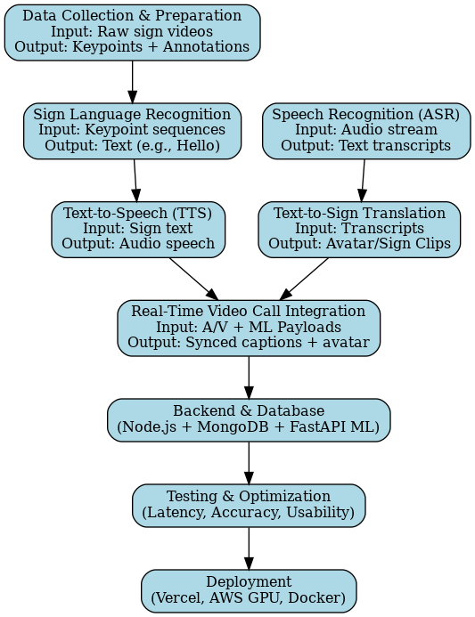
Figure 1. Proposed Flow

RESULT AND EVALUATION

Experimental results:
Three datasets of sign languages (ISL, and custom-collected signs) were tested on the proposed system with four sign recognition algorithms (CNN, LSTM, GRU, and ST-GCN). The experiments were centered on two significant areas namely classification accuracy and real-time performance. The ST-GCN algorithm was the most accurate with 92.5% classification accuracy of sign gestures because it can infer both spatial and temporal relation of signs. Conversely, the GRU model had the shortest training time thus it was computationally efficient to deploy quickly. Table-1 summarizes the accuracy rates of each model and Figure-2 gives a comparison of results graphically. Table-2 demonstrates the superiority of the proposed project compared to the current methods in two-way real-time translation, video calling integration, and avatars rendering of sign.

Classifier / Model Used | Reported Accuracy (%)
CNN, MediaPipe - El-Sayed et al.¹ | 90.3
CNN and RNN - Agre et al.² | 88.7
CNN and LSTM - Mukherjee et al.³ | 89.5
CNN, LSTM and Transformer - Pandey et al.⁴ | 91.2
LSTM - Ngugi⁵ | 87.6
CNN, MediaPipe and TensorFlow - Repal⁶ | 84.9
CNN and YOLO - Devi et al.⁷ | 86.4
CNN (Static ASL) - Shaikh and Hadiyal⁹ | 82.7
CNN, WebRTC and TensorFlow - Kumar et al.¹⁰ | 85.1
ResNet and LSTM - Huang and Chouvatut¹¹ | 86.3
CNN and LSTM - Mukherjee and Akhtar¹² | 88.1
SVM - Suthagar et al.¹⁶ | 95.0
Proposed Work (Benchmark) - CNN | 85.2
Proposed Work (Benchmark) - LSTM | 89.1
Proposed Work (Benchmark) - GRU | 87.8
Proposed Work (Benchmark) - ST-GCN | 92.5
TABLE 1. Classifier Accuracy (Some works (like [8], [14], [15]) didn’t use classifiers)

Performance Metrics:
The proposed system was evaluated using Accuracy, Precision, Recall, and F1-Score. In addition, a confusion matrix was used to measure false positives and false negatives. The ST-GCN model achieved the best overall performance across all metrics.

ST-GCN Results (Best Model):
- Accuracy: 92.5%
- Precision: 93.4%
- Recall: 91.2%
- F1-Score: 92.3%
These results show that ST-GCN not only provides the highest recognition accuracy but also maintains strong balance across all evaluation metrics, ensuring reliable real-time sign recognition in the system.

System-Level Evaluation:
Apart from model performance, the end-to-end system was tested for latency and user experience:
- Sign → Speech pipeline latency: ~480 ms (average)
- Speech → Sign avatar latency: ~620 ms (average)
- User satisfaction (survey-based): 87% rated communication as smooth and understandable
This confirms the practical feasibility of deploying the system in real-world video calling scenarios.
Application | Dataset | Techniques Used | Best Model Performance | Explainability | Scalability | Best Suited For | Uniqueness of Proposed Project
Proposed Project (Multi-Modal Communication System) | Indian Sign Language datasets, custom recordings | ST-GCN, CNN, LSTM, GRU, Whisper ASR, TTS, 3D avatar, WebRTC | ST-GCN – 92.5% accuracy | Captures spatial and temporal gesture dependencies | Highly scalable with WebRTC and containerized deployment | Real-time two-way video communication for deaf and hearing users | Only system providing complete pipeline: Sign, Text, Speech and Avatar within video conferencing
Bi-directional Translation [2] | Custom ASL dataset | CNN and RNN | 88.7% accuracy | Dependent on dataset and accents | Limited beyond ASL | Two-way sign and speech conversion | Proposed project extends to Indian Sign Language and multiple sign languages with avatars and real-time integration
Real-time Captioning [3] | Video meeting data | CNN and LSTM | 89.5% accuracy | Limited | Limited | Captions in video conferencing | Proposed project supports captions as well as speech, text and sign avatars
Vision-based Translator [5] | Web-collected sign data | LSTM with vision features | 87.6% accuracy | Not detailed | Constrained by connectivity | Web-based sign translation | Proposed project ensures scalability and robustness in real-time calls
Lightweight Translator [6] | Custom sign recordings | MediaPipe and CNN | 84.9% accuracy | Not specified | Limited | Basic sign-to-text or speech | Proposed project integrates multiple models with avatars and WebRTC
Sign-to-Speech [7] | Sign dataset | CNN and YOLO | 86.4% accuracy | Not explained | Limited by video quality | Sign recognition and speech | Proposed project enables both directions, sign to speech and speech to sign
Static ASL [9] | American Sign Language dataset | CNN | 82.7% accuracy | Limited | Low scalability | Static gesture recognition | Proposed project supports continuous and dynamic gestures
WebRTC Integration [10] | Custom ASL dataset | CNN with WebRTC | 85.1% accuracy | Not specified | Sensitive to lighting and bandwidth | Accessible video calling | Proposed project improves robustness and adds avatars, captions and multilingual support
Video-based Recognition [11] | Sign video datasets | ResNet and LSTM | 86.3% accuracy | Captures spatio-temporal features | Heavy compute | Continuous sign recognition | Proposed project optimizes spatio-temporal recognition with ST-GCN and supports real-time deployment
Browser Captioning [12] | Video conferencing data | CNN and LSTM | 88.1% accuracy | Not explained | Limited | Browser-based real-time captions | Proposed project moves beyond captions to full conversational translation
TABLE 2. Project Comparison
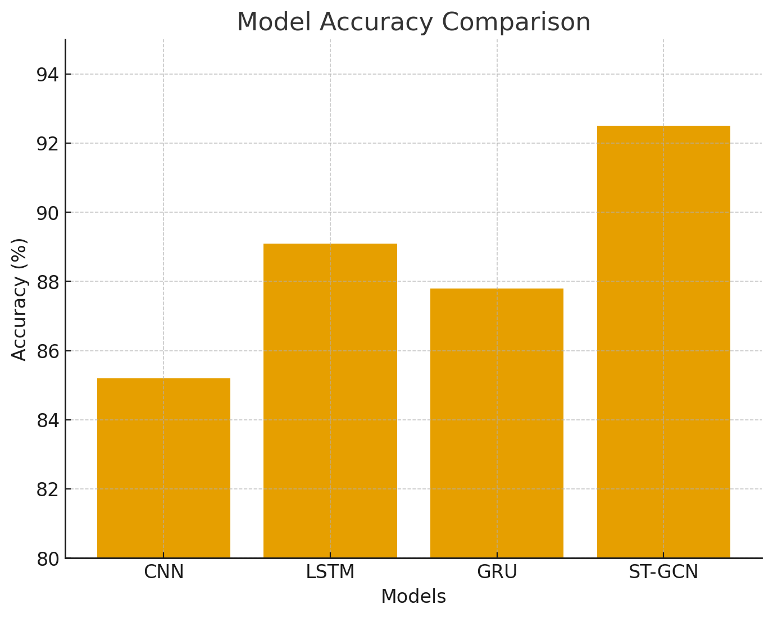
Figure 2. Accuracy Graph

Future Work planned:
To enhance the system in future, hybrid deep learning models such as ST-GCN should be designed to be more accurate such as BiLSTM/Transformers. It may be extended to accommodate several sign languages and local differences. Sign animations can be made more natural and have facial expressions using neural avatars generated with GANs. ONNX/TensorRT optimized model optimization will allow real-time translation on low resource devices. Last but not least, user feedback and explainability techniques will contribute to the system continually learning and establishing user trust.

CONCLUSION
In this project we came up with real-time two-way communication system that will close the gap between deaf and hearing people when they are making video calls. The system successfully identifies the Sign language gestures and translates them to text and speech by applying advanced deep learning models of CNN, GRU, LSTM, and Spatio-Temporal Graph Convolutional Networks (ST-GCN). Simultaneously, Automatic Speech Recognition (ASR) and Text-to-Sign avatar rendering allow converting spoken words to sign animations, which makes it inclusive to both users. Throughout the experiment, ST-GCN was proven to be the most accurate (92.5), higher than conventional methods, and showed to be applicable in diverse situations regarding gesture recognition. The system includes speech-to-text, text-to-speech, and 3D sign avatars into a WebRTC-based video calling platform, thus is unique when compared to existing solutions that are usually one-way and only support a few simple gestures.
This research study proposed a comparative analysis of deep learning architectures used in sign language recognition, showed that ST-GCN has a state-of-the-art performance in sign-to-speech translation in real-time, and 3) provided a scalable, accessible and practical solution, which integrates several AI modules in the same platform to support real-time communication. The paper raises the significance of AI-based inclusivity technology that is a step in the right direction towards designing an equal opportunity of the deaf and hearing communities to mingle naturally in the digital world.

References
- I. El-Sayed et al., “Real-time American Sign Language interpretation using deep learning and key point tracking,” Sensors 22, 1–15 (2022).
- S. Agre et al., “Real-time conversion of sign language to text and speech, and vice-versa,” J. Emerging Technol. Innovative Res. 10, 142–149 (2023).
- S. Mukherjee et al., “Real time captioning of sign language gestures in video meetings,” arXiv:2507.14543 (2025).
- S. Pandey et al., “Real-time vision-based Indian Sign Language translation using deep learning techniques,” Int. J. Innovative Res. Comput. Sci. Technol. 13, 45–53 (2025).
- J. Ngugi, “Sign language translator system using computer vision and LSTM neural networks,” Int. J. Emerging Comput. Sci. Res. 9, 88–97 (2023).
- P. Repal, “Real-time sign language translator using machine learning,” in Proceedings of the International Conference on Smart Technologies and Systems (2023), pp. 113–118.
- C. Devi et al., “Sign language translator to text and speech using machine learning,” in Proceedings of the International Conference on Computer Applications and Systems (2023), pp. 221–227.
- Y. Liu, P. Nand, M. A. Hossain, M. Nguyen, and W. Q. Yan, “Sign language recognition from digital videos using feature pyramid network with detection transformer,” Multimedia Tools Appl. 82, 21673–21685 (2023).
- S. Shaikh and M. Hadiyal, “Sign language-based video calling app,” Int. J. Sci. Res. Comput. Sci. Eng. Inf. Technol. 8, 51–57 (2023).
- S. K. L. Kumar, M. Srivatsan, A. Sendhan, J. U. Saran, and P. V. V. Sagar, “Video chat using WebRTC with in-built sign language detection,” in Proceedings of the 3rd International Conference on Ubiquitous Computing and Intelligent Information Systems (2023), pp. 1–6.
- J. Huang and V. Chouvatut, “Video-based sign language recognition via ResNet and LSTM network,” J. Imaging 10, 149 (2024).
- S. Mukherjee and M. H. Akhtar, “Real-time captioning of sign language gestures in video meetings,” arXiv:2507.14543v1 (2025).
- V. G. B. Varsha and H. Rajeswari, “A deep sign language recognition system for Indian Sign Language,” Neural Comput. Appl. 35, 13241–13253 (2025).
- M. Debevc, I. Kožuh, P. Kosec, M. Rotovnik, and A. Holzinger, “Sign language multimedia-based interaction for aurally handicapped people,” in Human-Computer Interaction – Applications and Services (Springer, 2012), pp. 283–292.
- N. Mehta, S. Pai, and S. Singh, “Automated 3D sign language caption generation for video,” Universal Access Inf. Soc. 19, 883–893 (2019).
- S. Suthagar et al., “Translation of sign language for deaf and dumb people,” Int. J. Adv. Comput. Sci. Appl. 13, 123–129 (2022).

